[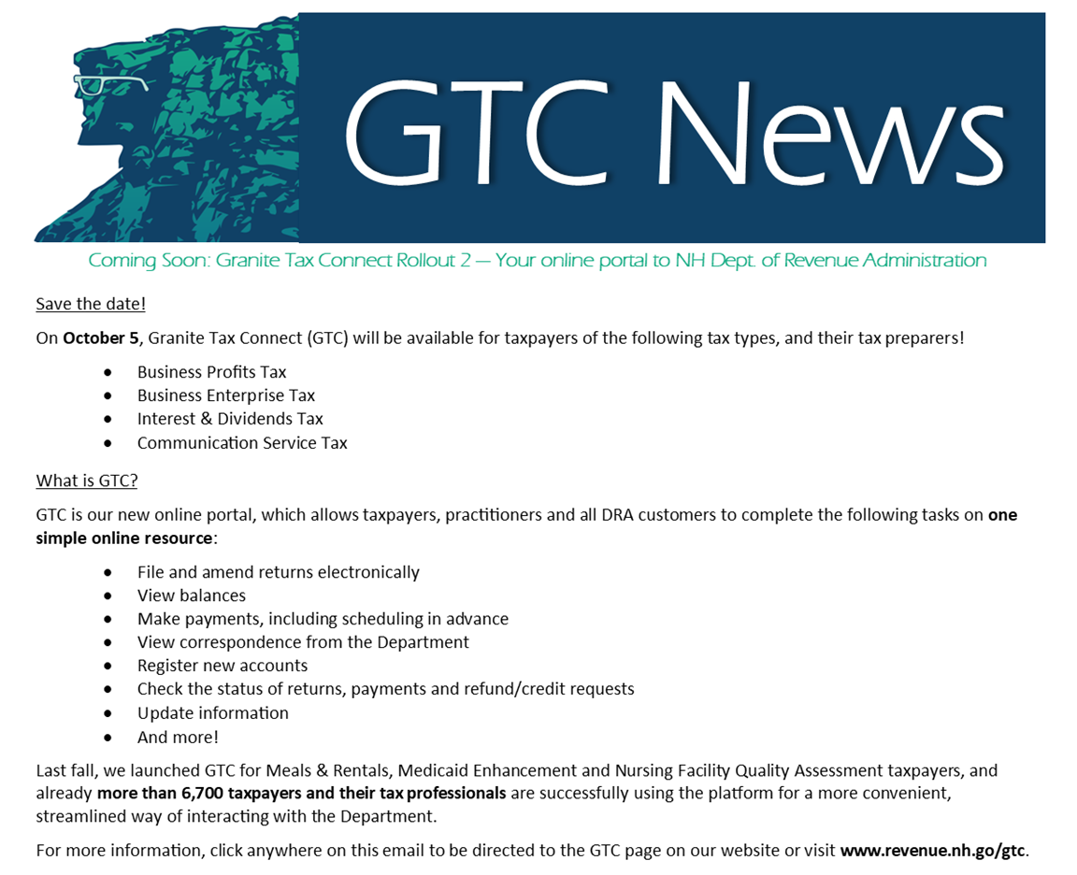](https://www.revenue.nh.gov/gtc/index.htm)