|  |  |  |  |  |
| --- | --- | --- | --- | --- |
| Y |  | |  | | --- | | **Upcoming Seminars** | | Oct. 8-9, 2020  Dec. 3, 2020 | |
|  |  |  |
| **NATP – the organization for tax professionals WEBSITE: natptax.com** |  | **NH Website: NHNATP.com** |

**\* * IMPORTANT MESSAGE * \***

**We definitely want this seminar to go on as scheduled, but, at the present time, we have extremely low registration numbers. So, if you are planning on attending, please register as soon as possible so that we don’t have to cancel the seminar.**

**Wearing Masks are Mandatory at the Seminar.**

**Bringing your own sanitizer is suggested.**

**Hotel will provide social distancing and sanitizing the facility.**

**NH NATP FALL SEMINAR AND ANNUAL MEETING**

WHEN: October 8, 2020 8:20 AM to 4:20 PM

October 9, 2020 8:30 Am to 12:20 PM

WHERE: Holiday Inn, 172 No. Main St., Concord, NH **SAFE, SOCIAL-DISTANCING**

HOW: Education Packets will be delivered electronically to all attendees registered by October 6, 2020

COST: Before September 9, 2020: Members $200 Non-Members $220

After September 8, 2020: Members $230 Non-Members $250

Paper Materials $25 (request when registering online)

**11 CPE hours**

Register online at https://natptax.com/Chapters/Pages/NewHampshireChapterEducation.aspx

By Mail: NATP, PO BOX 8002, Appleton, WI 54912

Once again, favorites, **David and Mary Mellem** of Ashwaubenon Tax Professionals of Green Bay, WI will be the instructors.

**TOPICS:**

DEBT CANCELLATION – examination of Forms 1099-C and 1099-A

LAWSUITS - Taxable Income? Deductible Legal Expenses?

OPENING A BUSINESS – Is it a Hobby? Business Structure? Recordkeeping?

CLOSING A BUSINESS – Inform who? When? Tax Consequences?

INHERITED PROPERTY – Basis of inherited assets? Special rules?

FEDERAL TAX UPDATE – New Legislation. Case law developments. Revenue rulings.

BANKRUPTCY – Laws and taxes. Discharges. Short years. Carryovers.

ETHICS – Issues of Circular 230. Recent cases.

***REGISTER TODAY! THIS WILL BE ANOTHER GREAT SEMINAR***

**______________________________________________________________**

**Greetings!**

Thanks to our Board and Members, the NH Chapter has been awarded Honorable Mention for 2020 Chapter of the Year Award! We had 3 events in 2019 with a member participation rate of 42.79% - impressive for our small chapter! The Certificate and Chapter of the Year Numbers are attached!

It has certainly been an interesting year with the everchanging tax season and Covid-19 restrictions. Tax season was lengthy with new challenges, but we are looking forward to future opportunities for the Chapter.

As things are continuously changing, the board is pleased to offer in person seminar October 8 & 9 at the Holiday Inn featuring Mary and Dave Mellem. This 1 ½ day seminar is an excellent opportunity to catch up with the latest federal changes along with other topics of interest: Debt Cancellation, Lawsuits, Opening and Closing a Business, Inherited Property Federal Tax Update, Bankruptcy and Ethics, with 11 CPE’s! This will be an excellent opportunity for learning, networking and to see friends as things open up!

We are working with the Holiday Inn to secure a safe environment encompassing the latest of the Covid-19 guidelines. The buffet will be no longer, plated meals instead, and we will be practicing safe distancing, mask mandate, among others.

Our Annual Meeting with nomination and election of officers will be on Thursday, October 8th. We invite you to consider joining our board even though we are in the midst of a challenging environment. We could use your thoughts, ideas, and expertise to develop opportunities for our Chapter! We have met more often this year due to Covid-19. We are currently using the Zoom platform to conduct these meetings. Usually we meet several weeks before the three training seminars and a brief meeting after each seminar.

You are most welcome to join any of our meetings to learn what is involved to provide our exceptional seminars! After a year, board members who attend the meetings and contribute are entitled to perks - local seminars are free and partial reimbursement when member travels to National Conference or Forums. The Conference and Forums enable first-hand exposure to a wide range of speakers, some that we later contract for our local NH seminars.

We hope to see you in October. In the meantime, stay safe. Please let us know if you have any questions, I can be reached at [bbowen704@gmail.com](mailto:bbowen704@gmail.com).

Cordially,

Betsy Bowen

President

NH NATP

_________________________________________________________________________________

**NCCPAP endorses tax preparer regulation**

The National Conference of CPA Practitioners has endorsed legislation to give the Treasury and the Internal Revenue Service the authority to regulate tax preparers.

In a letter to Sens. Chuck Grassley, R-Iowa, and Ron Wyden, D-Oregon, and Reps. Kevin Brady, R-Texas, and Richard Neal, D-Massachusetts, the organization urged them to pass S.1192/H.R.3330, “The Taxpayer Protection and Preparer Proficiency Act,” or incorporate its provisions in some other bill.

“This legislation could not be timelier,” NCCPAP president Neil Fishman and Tax Policy Committee co-chairs Stephen Mankowski and Sanford Zinman write in their letter. “Currently, anyone can start a business claiming that they prepare income tax returns for individuals and businesses. All that is required is for that individual to obtain a Preparer Tax Identification Number from the IRS; however, no one checks their level of competency.”

__________________________________________________________________________________



This Honorable Mention is for Second Place. Thank you to everyone in helping our Chapter achieve this distinction.

__________________________________________________________________________________



**Yes, YOU!**

**We are seeking interested members to join us on the Board of the NH Chapter of NATP.**

**Before COVID-19, we held a meeting in May and another in September where a scrumptious lunch was served. Other meetings were held at the end of the May, October, and December Educational Seminars.**

**Currently, Board meetings are being held via ZOOM.**

**As a member of the Board, you will be entitled to attend the May, October and December NH Chapter Education Seminars free of charge; you will be eligible for National Conference reimbursement; you will have input on the activities of the NH Chapter, and, most of all; you will be in the company of a cohesive unit of hard-working, dedicated, Board members. Committee assignments vary and aim to utilize your specific skills and interests.**

**Please consider joining today! Contact Betsy Bowen, our President at** [**bbowen704@gmail.com**](mailto:bbowen704@gmail.com) **or our Vice President, Susan Merrill-Paul, at** [**spaulea@gsinet.net**](mailto:spaulea@gsinet.net) **.**

___________________________________________________________________________________

**NH DEPARTMENT OF REVENUE OUTLINES THE TAXABILITY OF COVID-19 RELIEF**

**Press Release – August 18, 2020**

**Concord, NH – The New Hampshire Department of Revenue Administration (NHDRA) is helping** taxpayers understand the taxability of relief distributed to New Hampshire Business Profits Tax (BPT) and Business Enterprise Tax (BET) taxpayers as a result of the COVID-19 pandemic.

“More than 20 federal and state financial relief programs have helped businesses to continue operating under unprecedented circumstances” said NHDRA Commissioner Lindsey Stepp. “This continues to be a challenging time and we are committed to supporting our taxpayers as they navigate how these funds will be taxed and how to anticipate future financial obligations.”

State-level relief distributed to taxpayers required to file a BPT return – from the State of New Hampshire’s portion of the Federal CARES Act funds – should be included as income for BPT purposes. However, any state-level relief taking the form of a loan should not be included as income for BPT purposes, unless that loan is forgiven or otherwise discharged. Taxpayers may continue to take deductions, for deductible expenses of operating their business, even when those expenses were paid for with state-level relief.

Therefore, only the portion of these funds that are not spent on deductible business expenses will ultimately be subject to taxation. Expenses that are generally not deductible include distributions made to owners or shareholders, the payment of personal expenses of owners, or certain disallowed entertainment and meal expenses.

Additionally, any state-level relief received by taxpayers required to file a BET return that is utilized to pay wages or other compensation to employees, interest, or dividends shall be included in the enterprise value tax basis of the business and subject to BET.

A list of all state-level programs can be found on the GOFERR (State of New Hampshire Governor’s Office for Emergency Relief and Recovery) website: [www.goferr.nh.gov/covid-expenditures](http://www.goferr.nh.gov/covid-expenditures).

**NH Department of Revenue Administration – August 7, 2020**

The Department of Revenue Administration (DRA) will soon be launching the second rollout of the new Revenue Information Management System (RIMS) to modernize all aspects of the tax collection and payment process. RIMS will replace the current Tax Information Management System (TIMS) which was implemented nearly 30 years ago, is outdated, and therefore limited in its functionality. RIMS will be rolled out in three, phased implementations by tax types over the course of approximately three years. The second rollout will focus on Business Profits Tax (BPT), Business Enterprise Tax (BET), Interest and Dividends Tax (I&D), and Communications Services Tax (CST). *(see below)*

[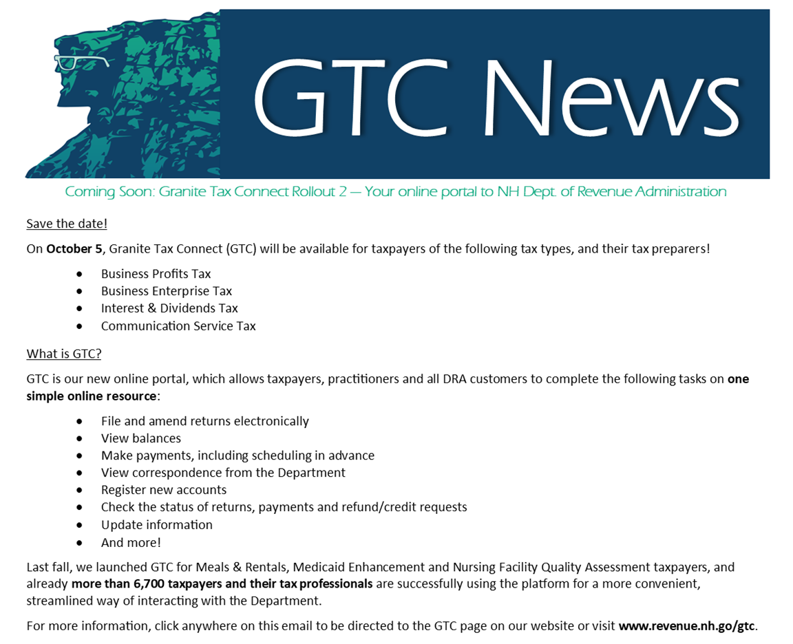](https://www.revenue.nh.gov/gtc/index.htm)

News from the IRS:

**CP-501, CP-503 and CP-504 Balance Due Letters**

The IRS has suspended the mailing of three notices – the CP-501, the CP-503 and the CP-504 – that go to taxpayers who have a balance due on their taxes. Although the IRS continues to make significant reductions in the backlog of unopened mail (originally estimated at 11 to 13 million pieces) that developed while most IRS operations were closed due to COVID-19, this temporary adjustment to processing is intended to lessen any possible confusion that might be associated with delays in processing correspondence received from taxpayers.

**IRS Form 1040-X**

e-filing of Form 1040-X (for 2019 only) is now functional as of August 17, 2020 through most software tax programs.

Stay safe and stay healthy.

**Your editors,**

**Norma Boyce, EA and Kimberly Perkins, EA**

**Keep up to date on the happenings of our Chapter by visiting these websites and FaceBook frequently:** [www.natptax.com](http://www.natptax.com) [www.nhnatp.com](http://www.nhnatp.com)



[This Photo](http://commons.wikimedia.org/wiki/file:facebook_shiny_icon.svg) by Unknown Author is licensed under [CC BY-SA](https://creativecommons.org/licenses/by-sa/3.0/)